

Assignment 1: Data Visualisation

Excel and Tableau

Deepa Patel | Data Technician Skills Bootcamp | 02/10/2024

Contents

Policies and Procedures 2

Excel 3

Protecting the workbook: 3

Displaying British Pound: 4

Changing Sheet To Table: 5

Filtering: 5

Creating a chart: 6

Editing a chart: 6

Moving a chart to a new sheet: 7

Sorting: 8

Bar Chart: 9

Background: 10

Macro: 11

Tableau 12

# Policies and Procedures

It’s important to be adhered to the following policies when working with data:

* Lawfulness, fairness and transparency - Processed lawfully, fairly and in a transparent manner.
* Purpose limitation - Collected for specified, express and legitimate purposes and not processed in a manner that is incompatible with those purposes.
* Data minimisation - Relevant and limited to what is necessary in relation to the purpose for which they are processed.
* Accuracy - Accurate and, where necessary, kept up to date; every reasonable step must be taken to ensure that personal data that are inaccurate, having regard to the purposes for which they are processed, are erased or rectified without delay.
* Storage limitation - Kept for no longer than is necessary for the purposes for which they are processed.
* Integrity and confidentiality (security) - Processed in a manner that ensures appropriate security of the personal data, including protection against unauthorised or unlawful processing and against accidental loss, destruction, damage, using appropriate technical or organisational measures.
* Accountability - The GDPR creates a principle of accountability for the Firm. This means that the Firm must maintain records to demonstrate its processing activities and its compliance with the data protection principles.

# Excel

## Protecting the workbook:

Click on the ‘File’ and then ‘Info’. Select ‘Protect Workbook’ and choose ‘Encrypt with Password’. A dialog is displayed with the option to enter a password. Enter ‘123’ and press ‘OK’. A confirmation dialog is displayed asking for the password to be re-entered. Re-enter the password and click ‘OK’.

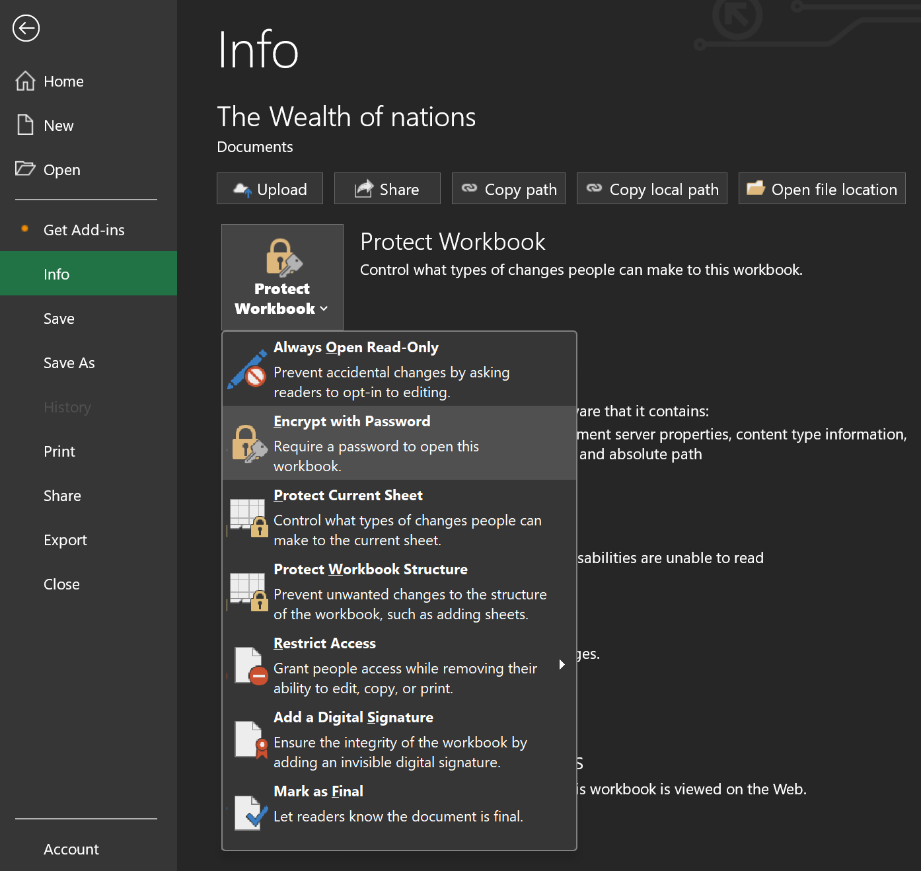

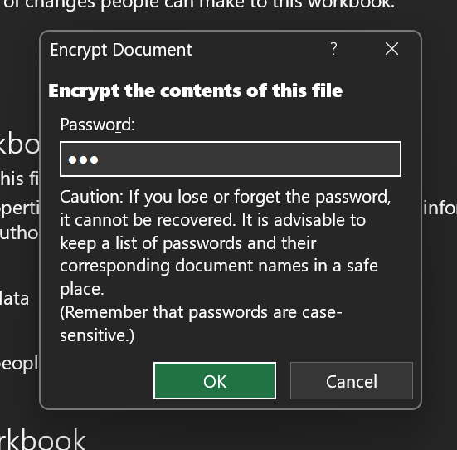 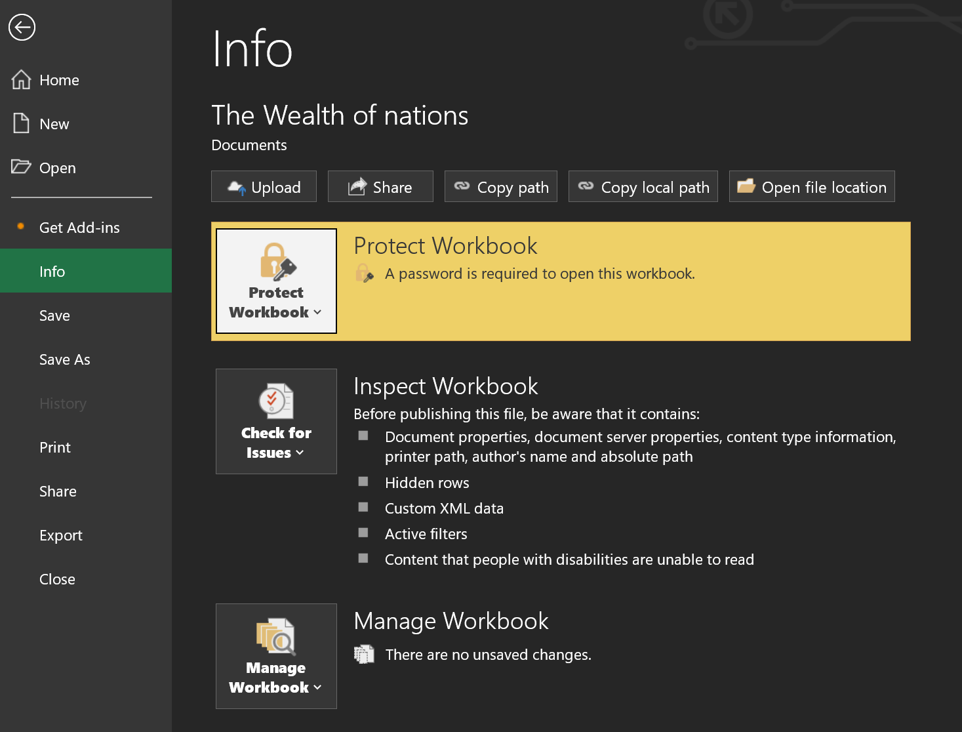

## Displaying British Pound:

Select column C. Click on ‘Number’ in the ribbon, and click on the arrow next to the money icon. Click ‘£ English (United Kingdom)’.

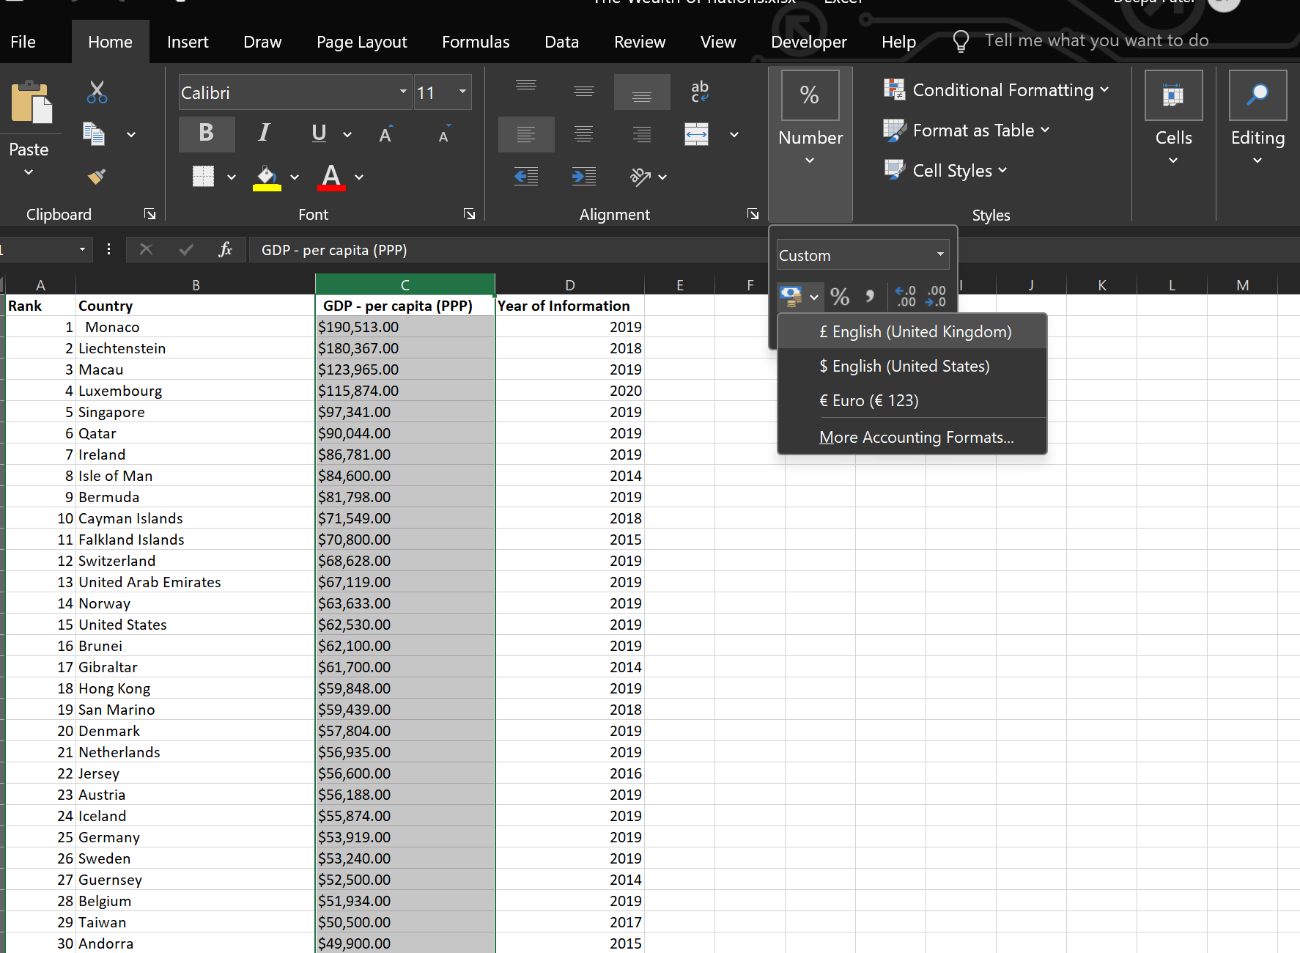

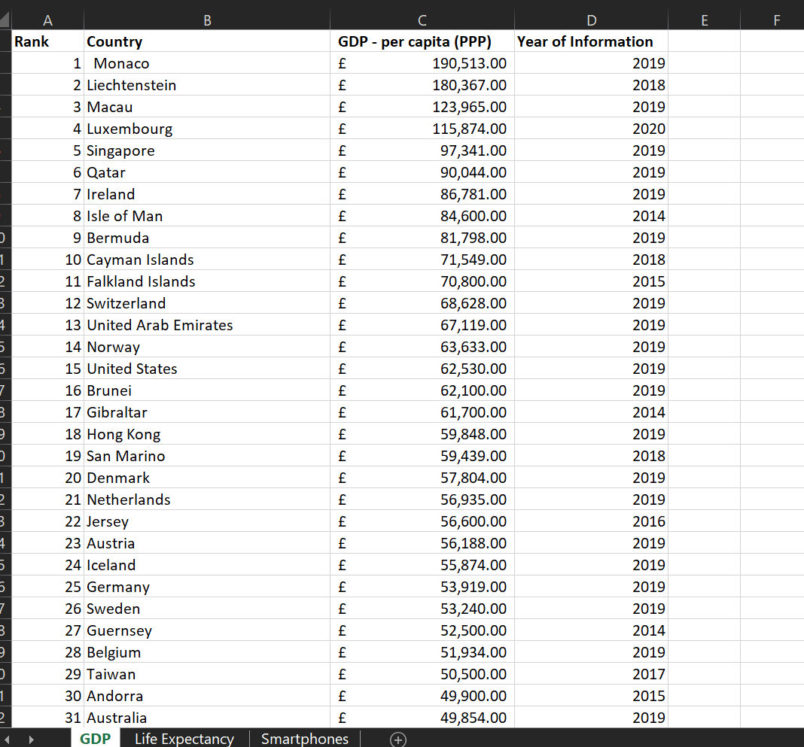

## Changing Sheet To Table:

Select the sheet and click on ‘Format as Table’ in the ribbon and select a design.

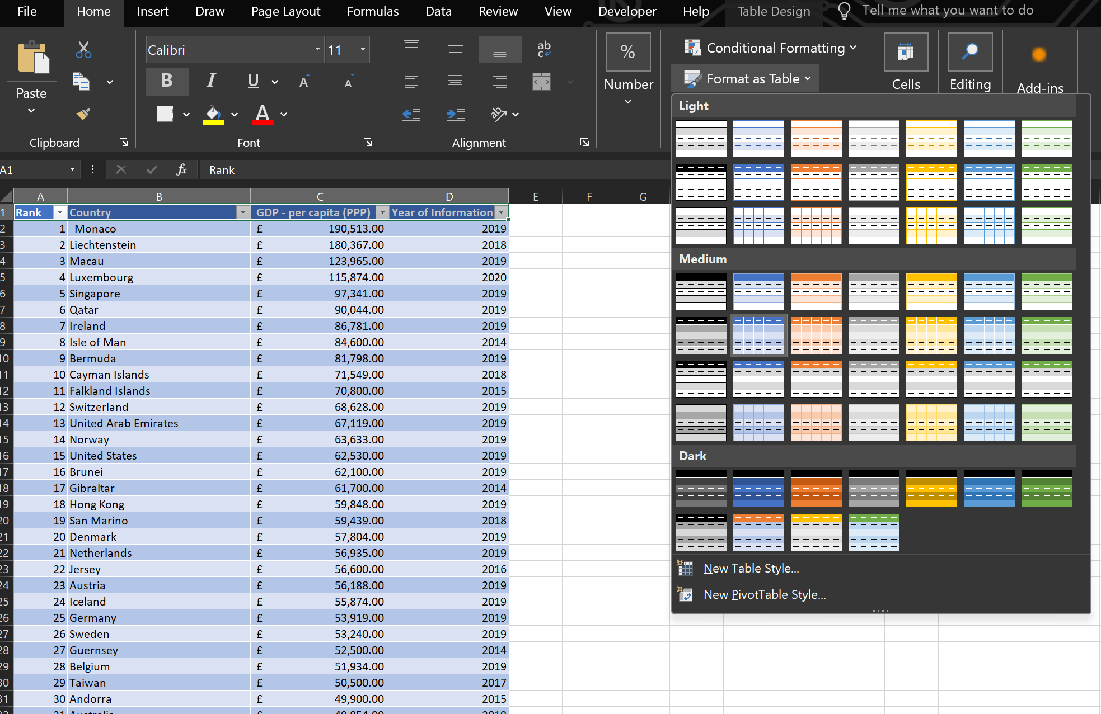

## Filtering:

Click on the arrow next to ‘GDP – per capita (PPP)’. Uncheck all filters except 2019. Click ok to apply to filter.

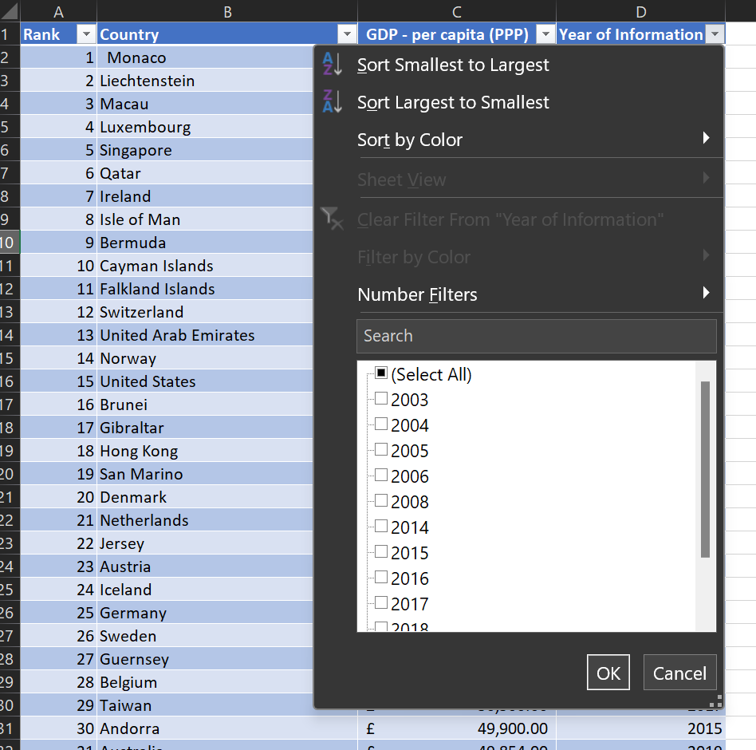 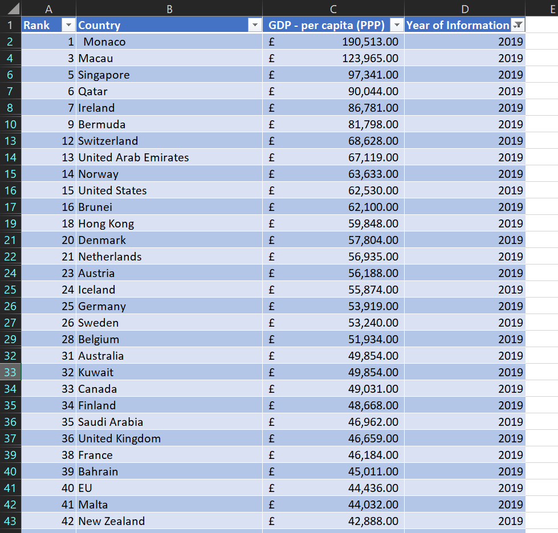

## Creating a chart:

Select the following columns ‘Rank, Country and GDP - per capita (PPP)’, and click on ‘Insert’, ‘Recommended Charts’. Click on the ‘All Charts’ tab to display more options. Select an appropriate chart and click ‘OK’.

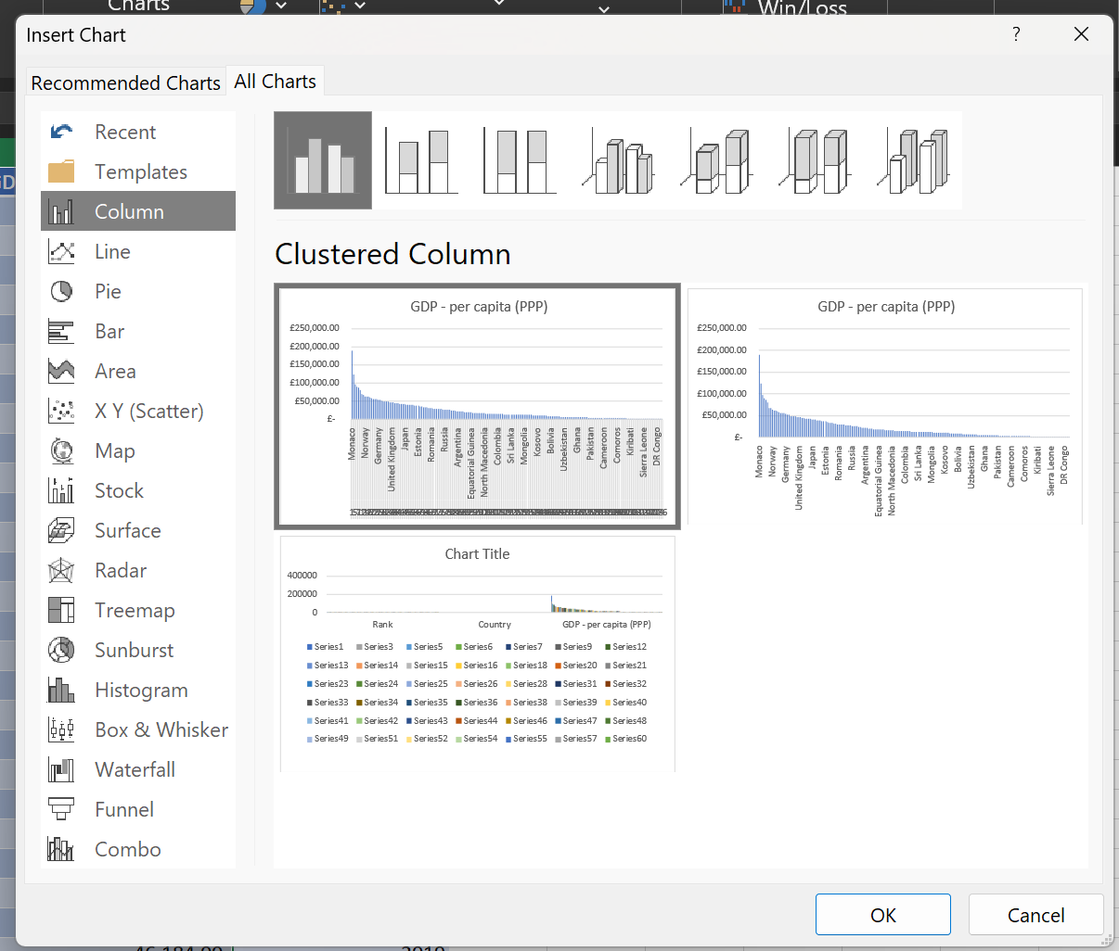 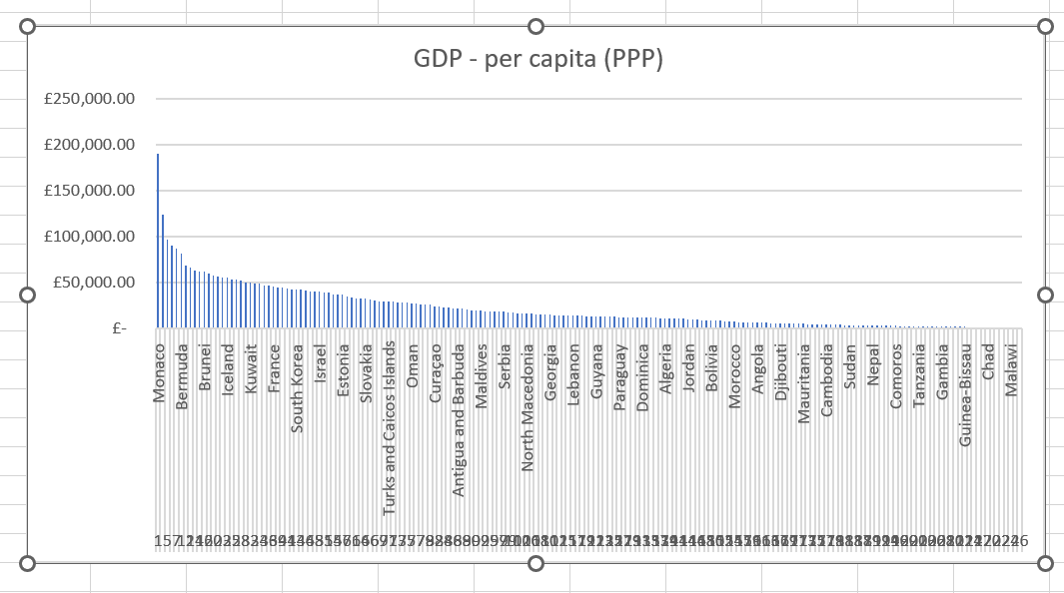

## Editing a chart:

Click on the chart, and then click on ‘Chart Design’ in the ribbon. Click ‘Add Chart Element’. Under ‘Axis Title’, click on ‘Primary Horizontal’ and ‘Primary Vertical’ to add the axis labels. Similarly, add the title by clicking on ‘Chart Title’. Click on the axis title to edit the text. To edit the colours of the chart, click on ‘Format’.

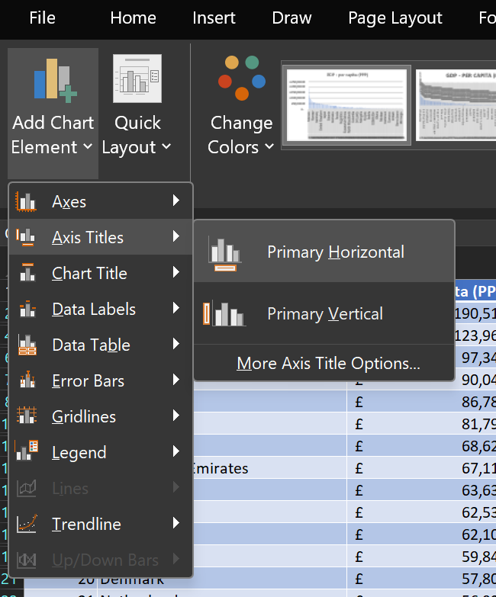

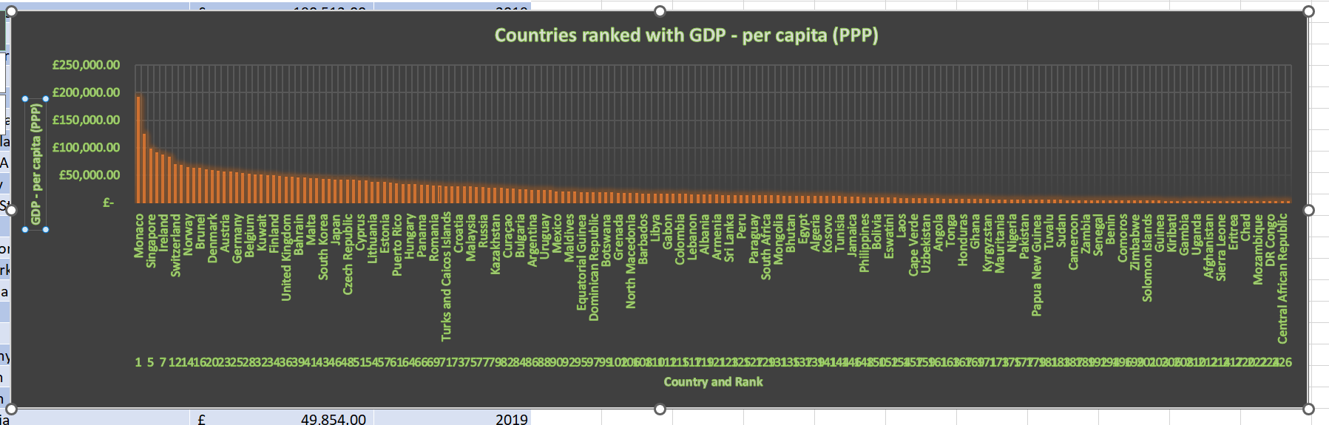

## Moving a chart to a new sheet:

Select the chart and click on ‘Chart Design’ in the ribbon. Click ‘Move Chart’. On the dialog, check ‘New sheet’, and enter ‘GDP – Chart’. Click ‘OK’.

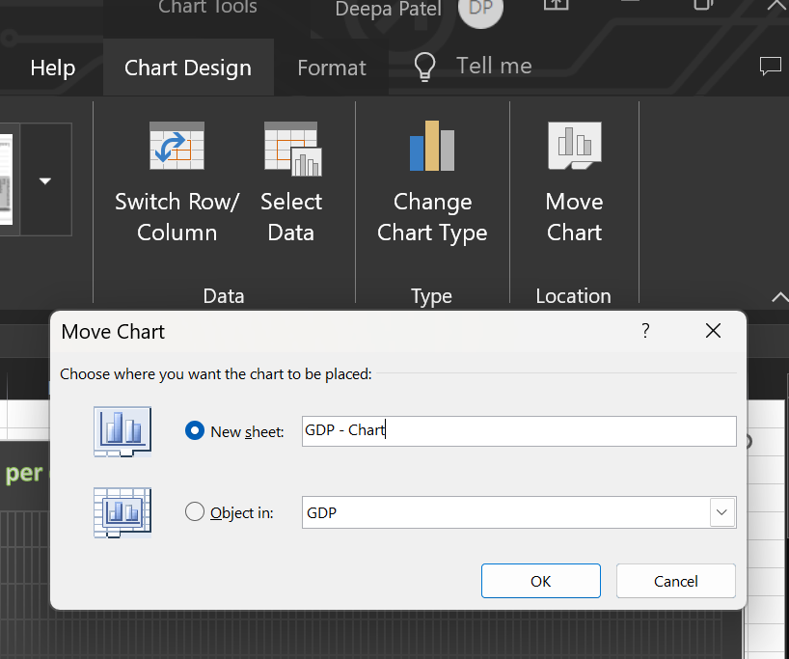 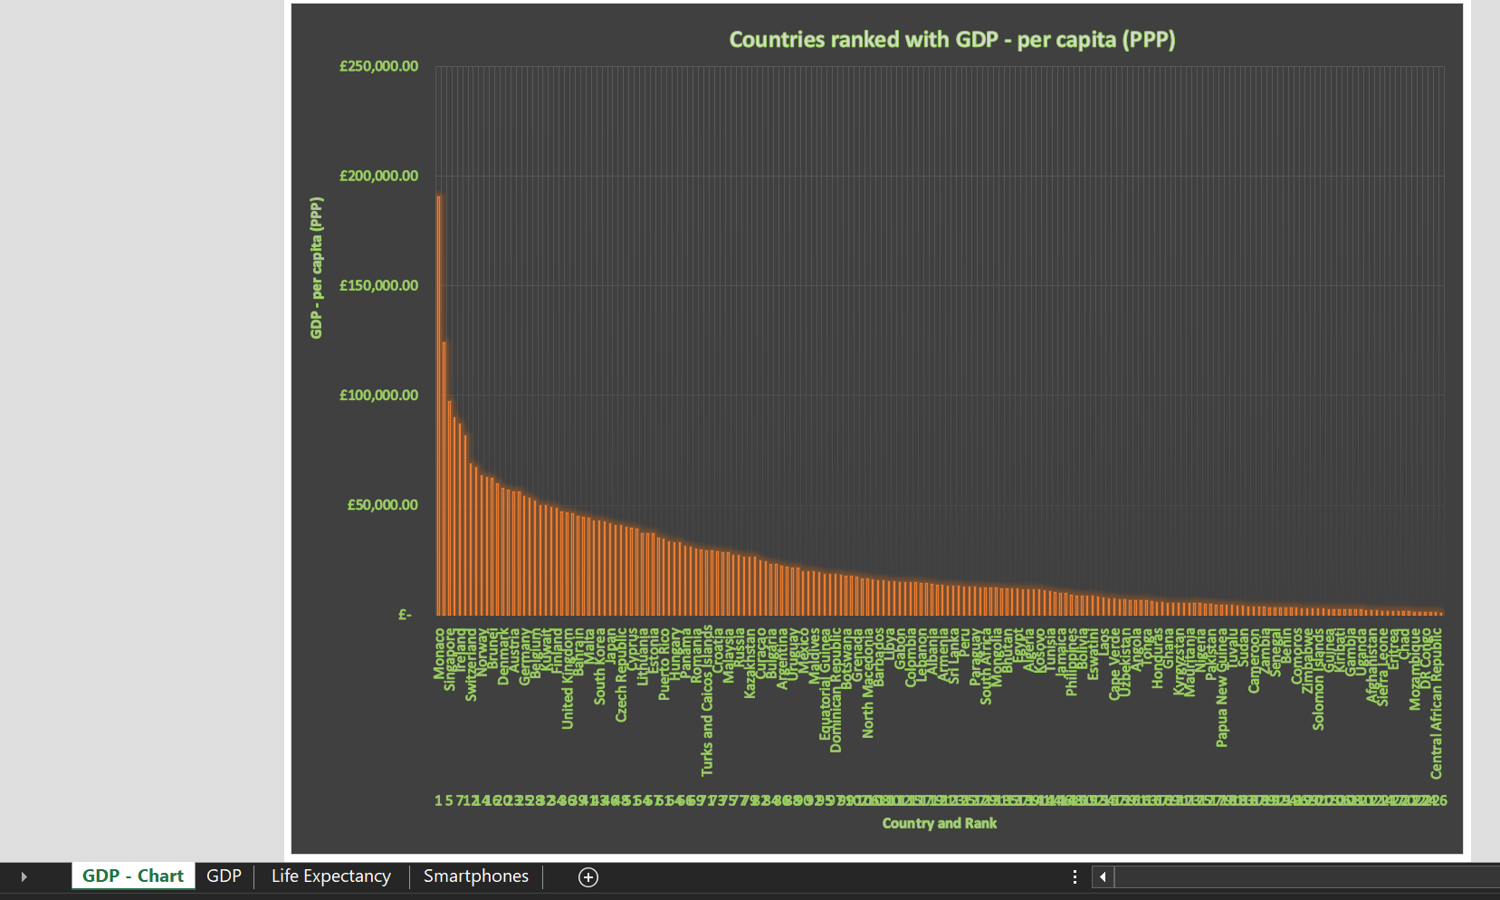

## Sorting:

Click on the arrow next to ‘Rank’ and click on ‘Number Filters’ and ‘Top 10…’. On the dialog that appears, increase the number to ‘20’. In this scenario, to view the top 20 ranked countries, select ‘Bottom’ in the dialog and click ‘OK’.

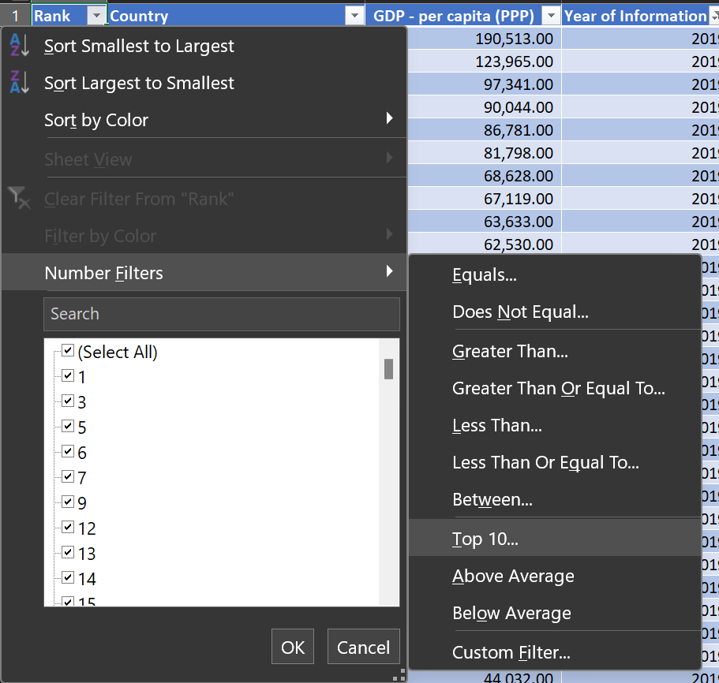 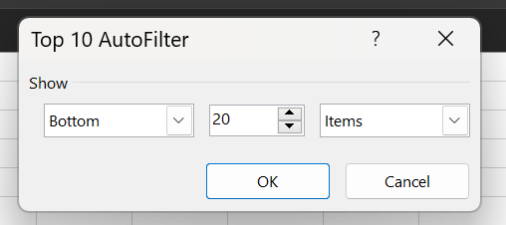

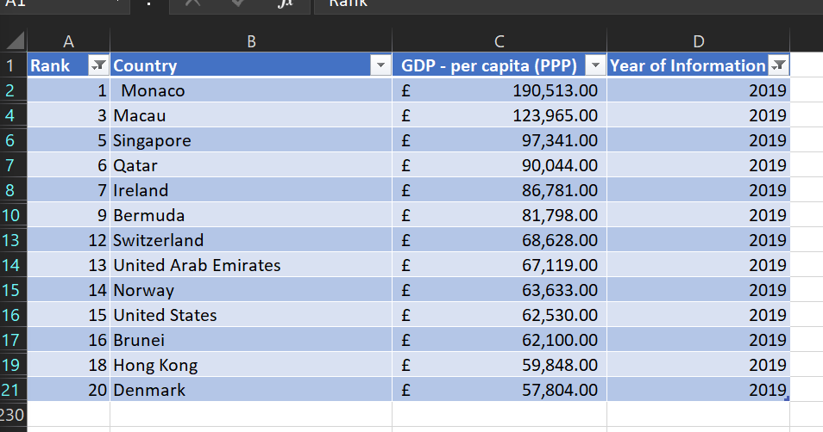

## Bar Chart:

Highlight the columns and click on ‘Insert’, followed by the bar chart icon. Pick an appropriate chart. Move the chart below the table.

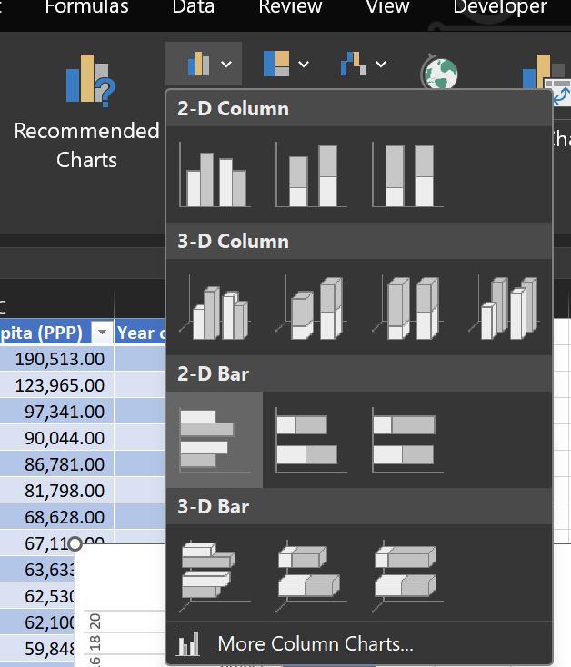 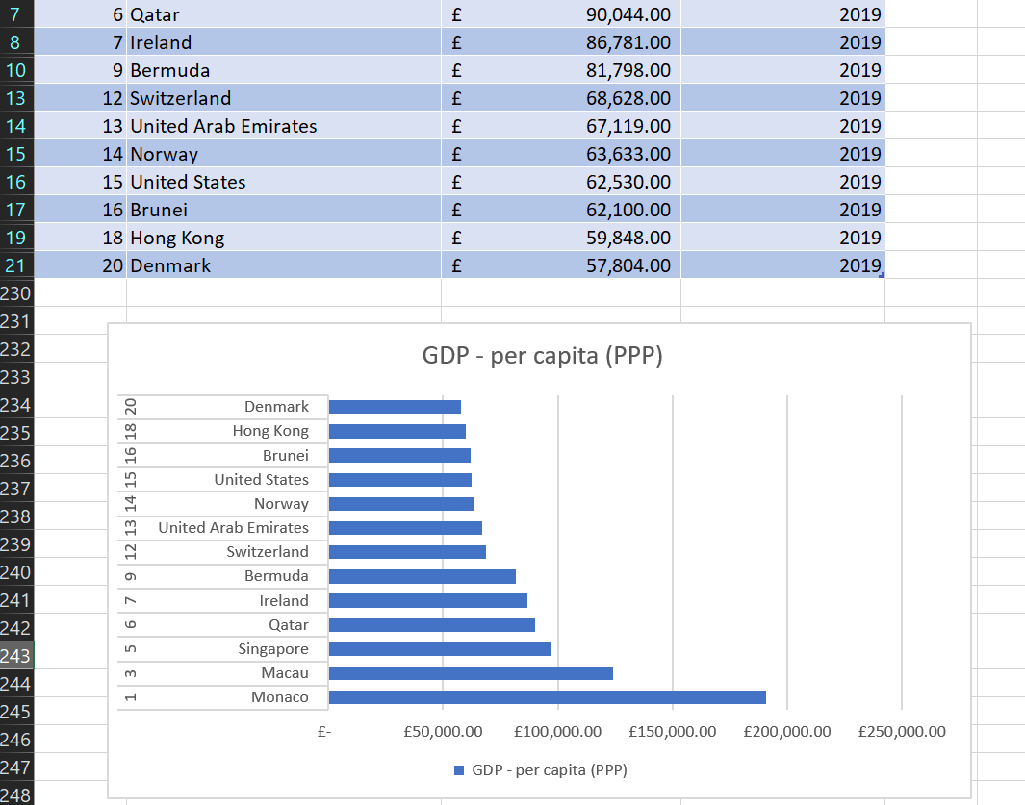

## Background:

Highlight the area underneath the table and behind the chart. Click on the fill icon in the ribbon, and select a colour.

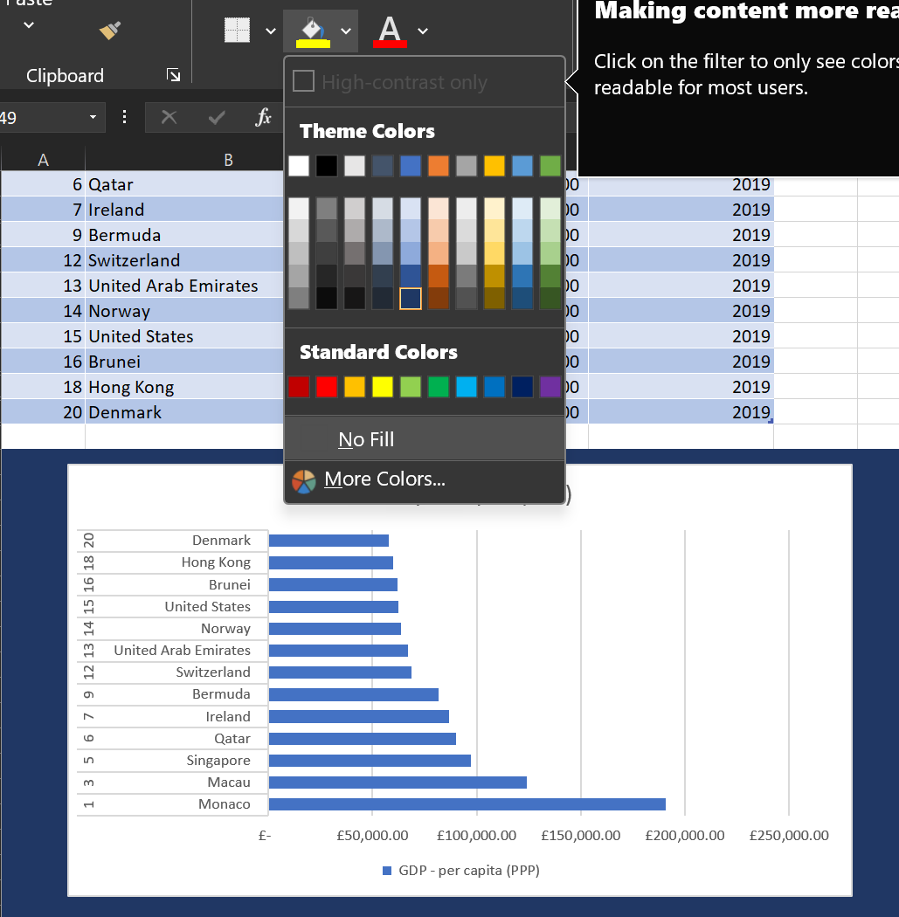

## Macro:

Click ‘Record Macro’ in the ribbon under ‘Developer’. Select cells to be copied. Right click and select copy. Click ‘Stop Macro’. Repeat with the steps to save and print, recording a new macro for each one. Draw 3 shapes. Right click on each button and click ‘Assign Macro’. Select one of the 3 for each shape.

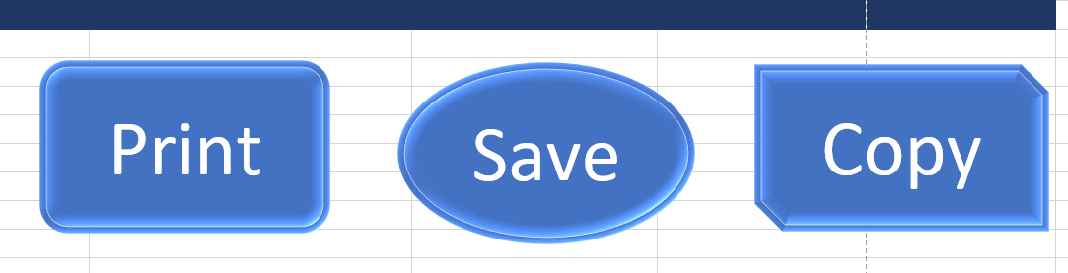

# Tableau

Launch Tableau and import the excel data file. Drag Life Expectancy to the RHS. Next drag GDP. At the bottom, set the relationship so that the countries equal each other on both sheets. Repeat with Smartphones.

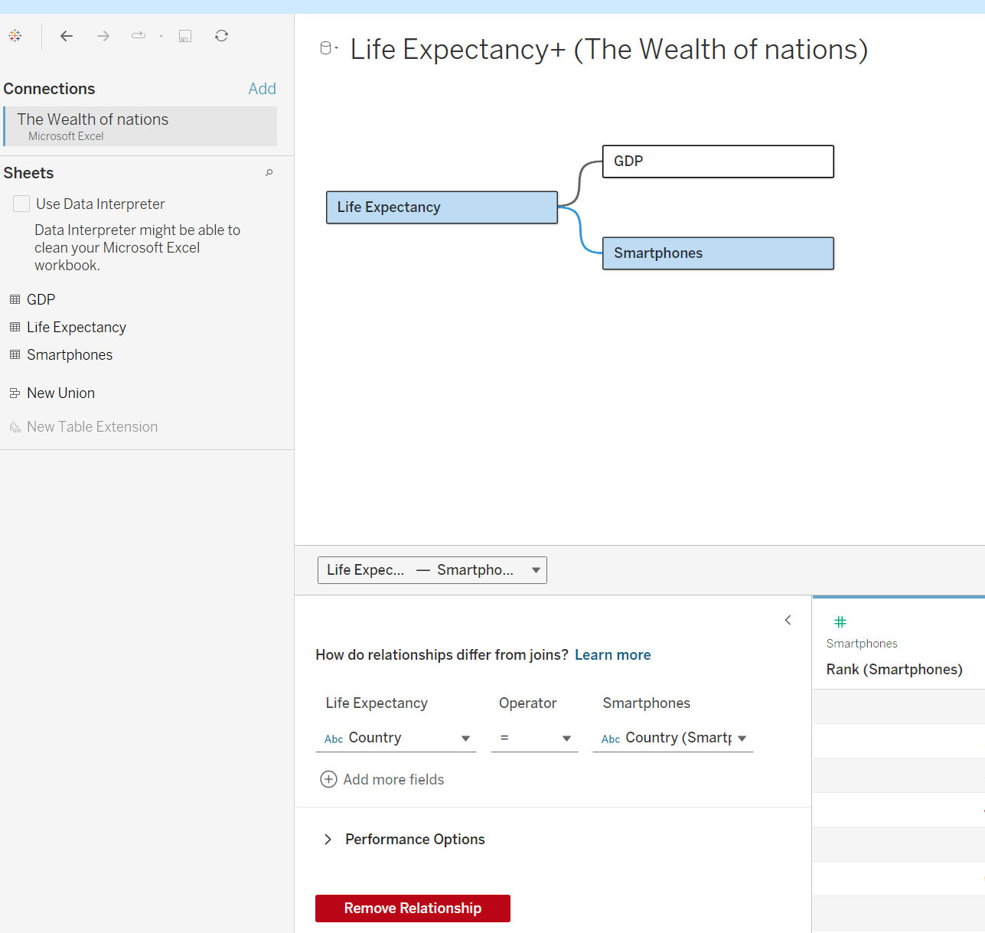

Create different charts and add them to a dashboard.

